

**Lab no.: 4 Date: February 11, 2023**

**Write a recursive program to find the steps for Tower of Hanoi game for given number of disc.**

Tower of Hanoi is a mathematical puzzle where we have three rods (A, B, and C) and N disks. Initially, all the disks are stacked in decreasing value of diameter i.e., the smallest disk is placed on the top and they are on rod A. The objective of the puzzle is to move the entire stack to another rod (here considered C), obeying the following simple rules:

* Only one disk can be moved at a time.
* Each move consists of taking the upper disk from one of the stacks and placing it on top of another stack i.e. a disk can only be moved if it is the uppermost disk on a stack.
* No disk may be placed on top of a smaller disk.



**Programming Language: C**

**IDE: Microsoft Visual Code**

**Source code:**

#include <stdio.h>

int toh(int n, char A, char B, char C)

{

if (n == 1)

{

output(1, A, C);

}

else

{

toh(n - 1, A, C, B);

output(n, A, C);

toh(n - 1, B, A, C);

}

}

void output(int n, char A, char C)

{

static int count = 1;

printf("%d. Move disc %d from %c to %c\n", count, n, A, C);

count++;

}

int main()

{

printf("....TOWER OF HANOI....\n");

printf("\nEnter the number of disc: ");

int n;

scanf("%d", &n);

printf("\nThe steps are: \n");

toh(n, 'A', 'B', 'C');

}

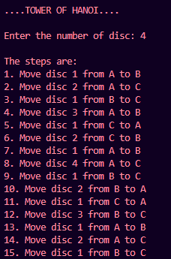

**Outputs:**

